**Biology STAAR Review Stations**

**Day 8**

**Category # 3 Biological Evolution and Classification (8.A, 8.B, 8.C)**

8.A define taxonomy and recognize the importance of a standardized taxonomic system to the scientific community.

8.B categorize organisms using a hierarchical classification system based on similarities and differences shared among groups.

8.C compare characteristics of taxonomic groups, including archaea, bacteria, protists, fungi, plants, and animals.

**8.A, 8.B, 8.C Pre-Test Score__________ Focus TEKS__________**

|  |  |  |  |
| --- | --- | --- | --- |
|  | **8.A** | **8.B** | **8.C** |
| **Interactive Quizzes** | **Taxonomy Quiz**  <http://ab.mec.edu/abrhs/science/bioweb/unit8/quiz_unit_8.html> | **Organizing Life’s Diversity**  [**http://glencoe.mcgraw-hill.com/sites/0078802849/student_view0/unit4/chapter17/standardized_test_practice-english.html**](http://glencoe.mcgraw-hill.com/sites/0078802849/student_view0/unit4/chapter17/standardized_test_practice-english.html) | **Kingdom Characteristics Interactive Table**  <http://glencoe.mcgraw-hill.com/olcweb/cgi/pluginpop.cgi?it=swf::550::400::/sites/dl/free/0078802849/383912/table17_3.swf::Kingdom%20Characteristics> |
| **Graphic Organizers** | **Linnean Classification Graphic Organizer**  See handout | | **Three Domains Graphic Organizer**  See handout |
| **Virtual Labs** | **How are living things classified?**  <http://www.glencoe.com/sites/common_assets/science/virtual_labs/E07/E07.swf> | **Evolutionary Trees Simulation**  <http://glencoe.mcgraw-hill.com/olcweb/cgi/pluginpop.cgi?it=swf::550::400::/sites/dl/free/0078802849/383941/Evolutionary_Trees.swf::Evolutionary%20Trees>  Watch the simulation and take a few notes. | **Dichotomous Key Activity**  <http://web.archive.org/web/20080721211717/http://www.students.ed.qut.edu.au/n2364379/MDB377/DichotomousKey.html>  Choose at least two animals from the group to classify using the dichotomous key.  Show results to the teacher. |
| **Vocabulary** | **Taxonomy**  [**http://quizlet.com/20531643/biology-taxonomy-flash-cards/**](http://quizlet.com/20531643/biology-taxonomy-flash-cards/) | **Classification**  <http://quizlet.com/1934970/classification-flash-cards/> | **Taxonomic Groups**  [**http://quizlet.com/35058554/taxonomic-groups-flash-cards/**](http://quizlet.com/35058554/taxonomic-groups-flash-cards/) |
| **Video Clips** | **Taxonomy and the Tree of Life**  [**https://www.khanacademy.org/science/biology/tree-of-life/v/taxonomy-and-the-tree-of-life**](https://www.khanacademy.org/science/biology/tree-of-life/v/taxonomy-and-the-tree-of-life) | **Classification Overview Video**  <http://www.youtube.com/watch?v=bZ8AUcbZOLY&edufilter=_2nXFUMaB1_cnY78uKT5qQ>  Take notes over the video while you watch.  **The Tree of Life Animation**  <http://glencoe.mcgraw-hill.com/olcweb/cgi/pluginpop.cgi?it=swf::550::400::/sites/dl/free/0078802849/383941/Visualizing_Tree_Life.swf::Visualizing%20the%20Tree%20of%20Life>  Watch the animation and take a few notes. Pause periodically to allow more time. | **Six Kingdoms Brain Pop Video and Quiz**  Watch the video and take the quiz. Show the quiz results to your teacher. |

**8.B Linnean Classification Graphic Organizer**

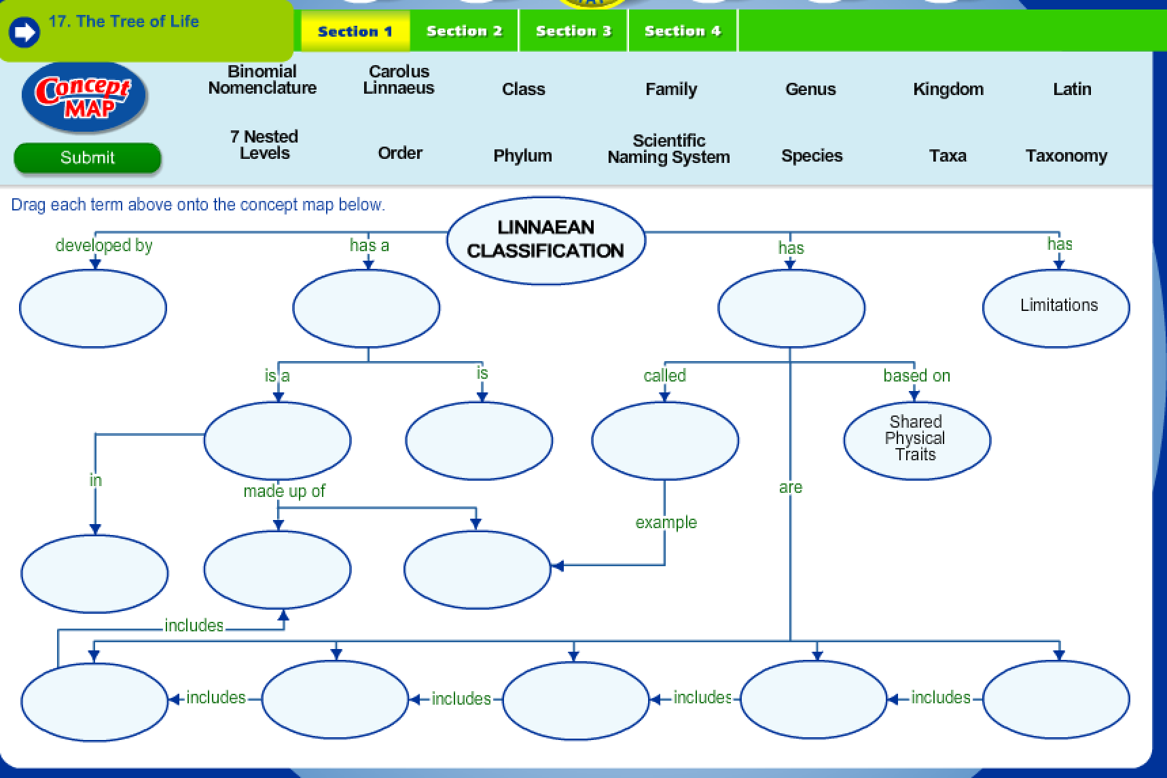

**8.C Three Domains Graphic Organizer**

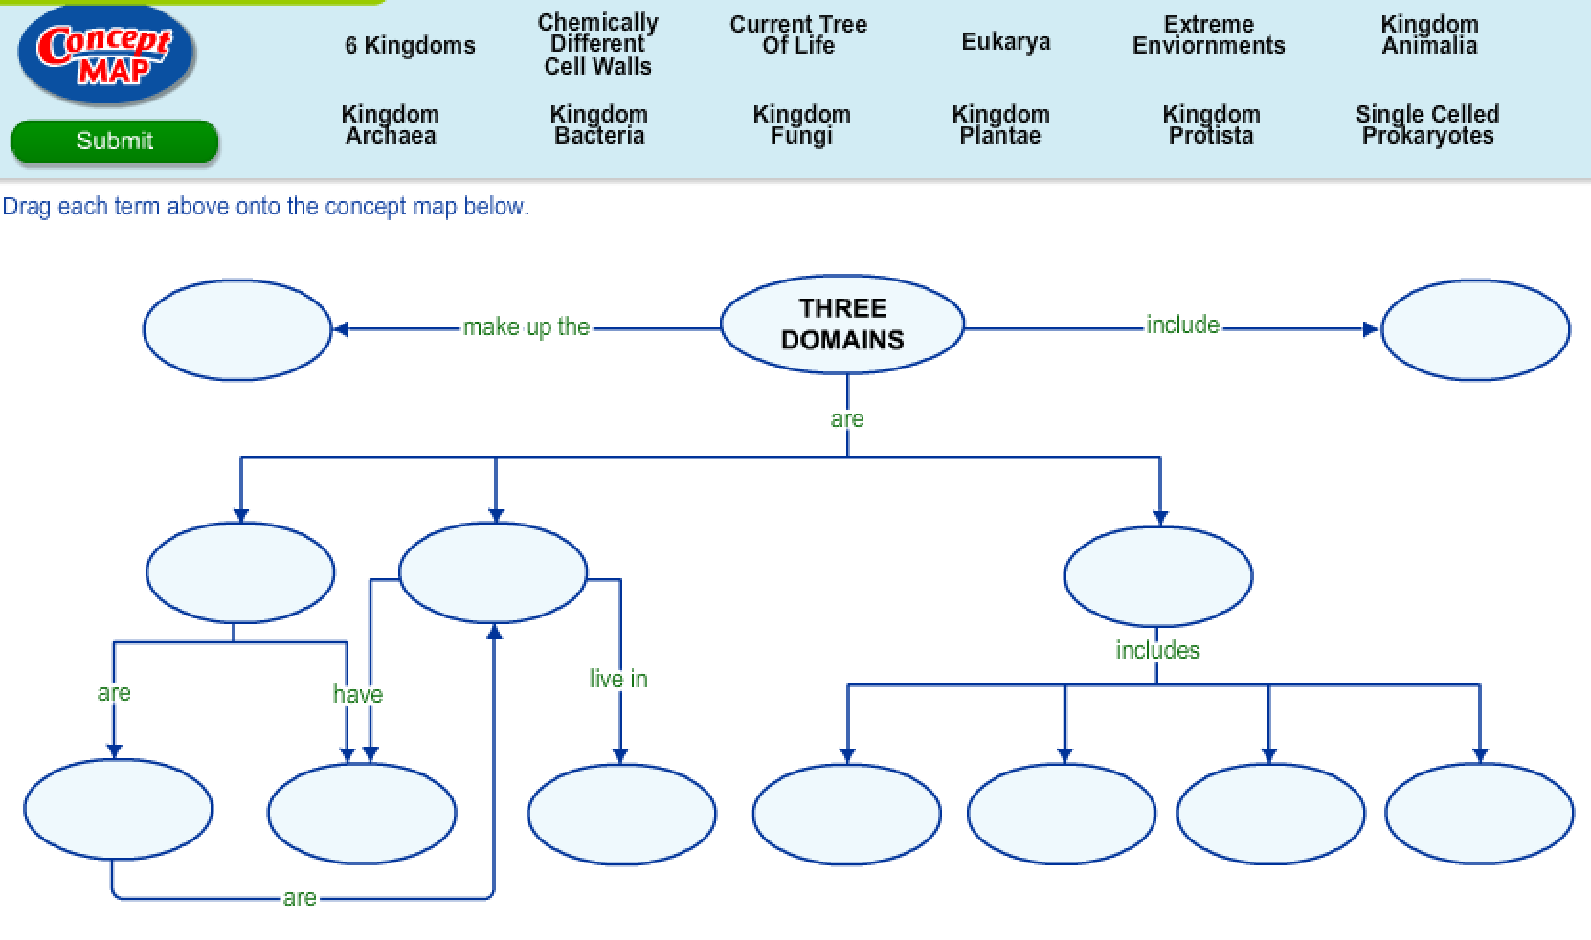

**Day 8 Review Questions**

8.A

_____1. The science of classifying living things according to their similarities is called:

1. physiology
2. zoology
3. classification
4. taxonomy

8.A  
_____2. Why is binomial nomenclature important for biological classification?  
http://glencoe.mheducation.com/olcweb/styles/shared/spacer.gif a. allows scientists to disregard common ancestors

http://glencoe.mheducation.com/olcweb/styles/shared/spacer.gif b. encourages scientists to use common nameshttp://glencoe.mheducation.com/olcweb/styles/shared/spacer.gif

c. provides all species with a specific namehttp://glencoe.mheducation.com/olcweb/styles/shared/spacer.gif

d. kingdoms are no longer necessary in classification

8.A

_____3. What is the importance of a standardized taxonomic system to the scientific community?

1. to have many different common names for one species
2. to analyze species genetic information
3. to organize species cells, tissues, organs, and organ systems
4. to have a universal naming system

8.A

_____4. Plants known as bluebells exist in England, Scotland and the United States. The plants known as bluebells differ greatly in each location. What does this statement demonstrate?

1. the need for controlling variables in experiments
2. the importance of predicting trends in populations
3. the need for classifying and naming organisms using a scientific system
4. the importance of questioning scientific evidence

8.B  
_____5. According to this, how many different taxa is the American black bear in?

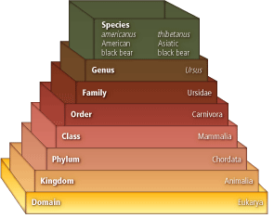

A)http://glencoe.mheducation.com/olcweb/styles/shared/spacer.gifsixteenhttp://glencoe.mheducation.com/olcweb/styles/shared/spacer.gif

B)http://glencoe.mheducation.com/olcweb/styles/shared/spacer.gifonehttp://glencoe.mheducation.com/olcweb/styles/shared/spacer.gif

C)http://glencoe.mheducation.com/olcweb/styles/shared/spacer.giffourhttp://glencoe.mheducation.com/olcweb/styles/shared/spacer.gif

D)http://glencoe.mheducation.com/olcweb/styles/shared/spacer.gifeight

8.B

_____6. A ____ is a group of species that are closely related and share a common ancestor.http://glencoe.mheducation.com/olcweb/styles/shared/spacer.gif

A)http://glencoe.mheducation.com/olcweb/styles/shared/spacer.gifgenushttp://glencoe.mheducation.com/olcweb/styles/shared/spacer.gif

B)http://glencoe.mheducation.com/olcweb/styles/shared/spacer.giftaxonhttp://glencoe.mheducation.com/olcweb/styles/shared/spacer.gif

C)http://glencoe.mheducation.com/olcweb/styles/shared/spacer.gifkingdomhttp://glencoe.mheducation.com/olcweb/styles/shared/spacer.gif

D)http://glencoe.mheducation.com/olcweb/styles/shared/spacer.giftype

8.B

http://glencoe.mheducation.com/olcweb/styles/shared/spacer.gifhttp://glencoe.mheducation.com/olcweb/styles/shared/spacer.gif  
_____7. In this cladogram, which species shares ancestral characteristics with the three organisms being compared?

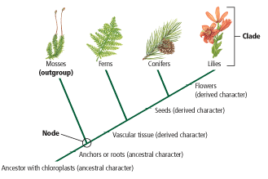

A)http://glencoe.mheducation.com/olcweb/styles/shared/spacer.giflilies

B)http://glencoe.mheducation.com/olcweb/styles/shared/spacer.gifferns

C)http://glencoe.mheducation.com/olcweb/styles/shared/spacer.gifconifershttp://glencoe.mheducation.com/olcweb/styles/shared/spacer.gif

D)http://glencoe.mheducation.com/olcweb/styles/shared/spacer.gifmosses

8.B

http://glencoe.mheducation.com/olcweb/styles/shared/spacer.gifhttp://glencoe.mheducation.com/olcweb/styles/shared/spacer.gif  
_____8 What morphological characters suggest the evolutionary similarity of birds and dinosaurs?  
a. bird feathershttp://glencoe.mheducation.com/olcweb/styles/shared/spacer.gif

b. dense bones

c. hollow boneshttp://glencoe.mheducation.com/olcweb/styles/shared/spacer.gif

**d.** DNA similarities

8.C

_____9. Which Kingdom exhibits the following traits: multicellular, eukaryotic, cell walls, no photosynthesis, non-mobile organisms including mushrooms and mold.

1. Protista
2. Plantae
3. Animalia
4. Fungi

8.C

_____10. What characteristics of the plant kingdom distinguishes them from the animal kingdom?

1. use of mRNA during protein synthesis
2. storage of energy in chemical bonds
3. water exchange in the environment
4. use of chlorophyll during photosynthesis

8.C

_____11. Multicellular eukaryotes that are usually mobile and obtain food from other organisms most likely belong to what kingdom?

1. Plantae
2. Fungi
3. Protista
4. Animalia

8.C

_____12. All plants and fungi are similar in the following:

1. have cell walls
2. have stems
3. grow from the soil
4. perform photosynthesis

**Day 8 Review Questions (8.A, 8.B, 8.C)**

**Answer Sheet**

**_____1.**

**_____2.**

**_____3.**

**_____4.**

**8.A Score__________/4**

**_____5.**

**_____6.**

**_____7.**

**_____8.**

**8.B Score__________/4**

**_____9.**

**_____10.**

**_____11.**

**_____12.**

**8.C Score__________/4**

**Day 8 Review Questions (8.A, 8.B, 8.C)**

**Key**

**__D__1.**

**__C__2.**

**__D__3.**

**__C__4.**

**__D__5.**

**__A__6.**

**__D__7.**

**__C__8.**

**__D__9.**

**__D__10.**

**__D__11.**

**__A__12.**